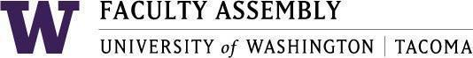

Agenda
Faculty Affairs Committee Meeting
May 20, 2024 / 12:30pm-1:20 p.m.
Zoom

- Recording Permissions/Consent [2 mins]
- Non-Tenure Track Faculty Forum [10 mins]
- Updates
- AY 2022-2023 priorities and status updates [10 mins]
- UWT Equity-Minded Faculty Workload Initiative
  - Final Report to FA – Process Report (end of May/early June)
Working on report. Will send electronic copy for FAC members to review and approve.
  - Final Report to FA – Data Results (Fall quarter)
  - Report Out to Schools
- Timing for delivering School-level reports
- Timing for meeting with Schools
- UWS Faculty Senate strong interest in faculty workload

- Elections: Next chair for FAC [15 minutes]

- Follow-up workload initiative – who should provide oversite of implementing equity-minded workload recommendations? [3 mins]

- AY 2024-2025 FAC priorities [5 mins]
- Preliminary discussions
Join Zoom Meeting
https://washington.zoom.us/j/96609919459

Dial by your location
+1 253 215 8782 US (Tacoma)

