**2023-2024 UWT Executive Council of the Faculty Assembly**

**Ad-hoc Safety Committee Report**

**Background**

Following a security incident on campus in winter 2023, the Executive Council (EC) issued a resolution to address the “safety and security of instruction and faculty” and provide a comprehensive plan “reviewed by the Executive Committee of the Faculty Assembly in consultation with UW Tacoma Decriminalize group and the UWT Administration” (see Appendix 1).

In their 6-14-23 response the UWT Administration affirmed the Vice Chancellor for Finance & Administration’s responsibility for faculty safety and outlined ongoing work with the Chancellor’s Advisory Committee on Reimagining Campus Safety (now known as the [Campus Community Safety and Advisory Committee](https://www.tacoma.uw.edu/chancellor/campus-community-safety-advisory-committee)) including a facility assessment, the completion of a [2023 Campus Safety Plan](https://www.tacoma.uw.edu/fa/safety), and other activities (Appendix 2).

In December 2023, the EC approved (12-08-23) the formation of an Ad-hoc safety committee to determine unit orientations to a safe campus and make recommendations about EC’s role in assuring campus safety. In this report we 1. Describe existing actions on security and safety for the faculty, 2. Summarize outcomes from the Administration’s Facility Assessment, and 3. Recommend future roles for the EC in campus safety planning.

**Safety Framework**

The committee adopted a working *Holistic Framework for Safety* (Figure 1) inspired by [UW’s approach to safety and well-being](https://www.washington.edu/safety/about-us/reimagining-safety-at-the-uw/) as “creating learning, working, and living environments… responsive to the different needs, as well as to the different experiences — some negative — that various community members have had with safety resources and personnel, both on and off of our campuses” and also responsive to workplace stressors that might predict harmful behaviors. These four dimensions are contextualized within a concern for faculty, staff, students, and the community (e.g., businesses and residents that rent UWT spaces or whose spaces surround campus). Campus safety relies on and emerges from safety for all these groups.

The framework includes four intersecting dimensions of safety:

1. Physical security, which involves buildings and other static structures on campus;
2. Relational safety, which involve policies, practices, and dynamic relationships that ensure bystander readiness through the facilitation of equity, inclusion, and belonging on campus;
3. Environmental design, which involves orientations of wellbeing and trauma-responsiveness in how the campus looks and feels; and
4. Environmental Health and Safety, which involves ongoing actions to adhere to workplace safety standards.

Figure 1: Holistic framework for safety

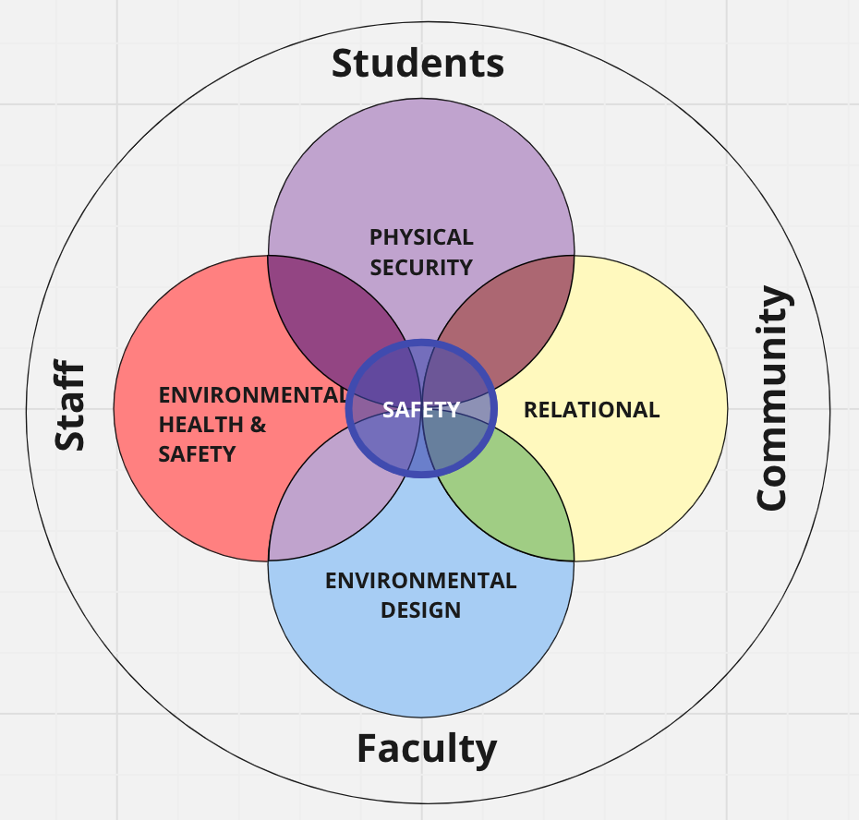

**Existing Actions on Safety: Challenges and Recommendations**

*Overall Concerns*: The existing UWT Campus Safety plan does not fully address the Holistic Framework for Safety nor does it adequately involve faculty.

Committee observations with identified challenges and recommendations are described below.

**Physical Security**

Physical security refers to the security of the physical buildings and grounds and the administrative infrastructure for security. [Campus Safety and Security](https://www.tacoma.uw.edu/fa/safety) manage the campus with unarmed security personnel and coordinate with Tacoma Police for armed responses if needed. During the 2023-2024 year the physical building and campus infrastructure were independently assessed by a federal agency, the Cybersecurity and Infrastructure Safety Administration (CISA). Campus Safety and Security supervised this assessment and ad-hoc committee members participated as observers.

***Observed Challenges***

1. The CISA assessment identified over 49 “vulnerabilities” to shooter, explosive, and other violent threats.
2. There is no budget for building wardens who were identified as a necessary component of the [2023 Workplace Security plan](https://www.tacoma.uw.edu/fa/safety/workplace-security-plan).
3. Faculty are undertrained in bystander awareness and largely unaware of the organizational structure of campus safety and security operations.

***Recommendations***

1. Build situational awareness and operational coordination to support faculty before, during, and after a crisis /emergency.
2. Apply the Holistic Framework for Safety in the development of a comprehensive security plan with an organizational chart.
3. Advocate for a UW-wide interactive safety application for mobile devices.

**Relational Safety**

Relational safety refers to being free from psychological, emotional, physical, and cultural harm and is achieved through just, empathic, and equitable relationships and communities among students, staff, and faculty. When communities are strong and vibrant, relationships are there to prevent and respond to harm. This form of safety is emphasized by the UWT Strategic Plan goals 2 (student well-being) and 8 (an accessible, equitable, respectful and inclusive campus experience).

Departments and projects that promote this type of safety include, but are not limited to: Center for Equity and Inclusion, Student Transitions and Success, Student Life, Title IX, SafeCampus, the CARE Team, PAWS and Telus, ASUWT, Huskies Care, and WholeU, and UWY (Appendix 4). Registered student organizations are also players in creating a safe campus. Various aspects of faculty also fall within this domain, such as class policies, pedagogy, the quality of relationships with students. Further, the [Campus Community Safety and Advisory Committee](https://www.tacoma.uw.edu/chancellor/campus-community-safety-advisory-committee) exists to “focus on safety, security, preparation issues on the UW Tacoma campus”.This committee has been coordinating with other regional safety partners in preparedness planning and involves faculty.

***Observed challenges***

1. Faculty remain undertrained in SafeCampus and CARE Team reporting, and
2. Systems for involving faculty, staff, students, and the community are siloed.

***Recommendations***

1. Meaningfully involve equity and inclusion-oriented entities (e.g. Center for Equity and Inclusion, RSO’s, and Student Success) in campus in safety and security planning, and
2. Provide threat assessment support for faculty when reporting a concern about disruptive or dangerous behavior in classroom or workplace.

**Environmental Design**

The design of the built and natural environment influences how people feel, act, and relate. Designed poorly, a space can increase stress and harmful behavior whereas a healthfully designed space can facilitate calm and supportive relationships. Involves an orientation to design and maintenance of Nature-involved (green, blue [water], sensory, social, active, and inclusive) spaces on our campus. Nature-involved designs restore health and wellbeing, improve resiliency in emergencies, decrease the impacts of personal stressors, and link students, faculty, and staff to their cultures and the story of the land.

UWT has a variety of nature-involved spaces on campus. The UWT Sustainability Committee promotes a culture of sustainability in which environmental, cultural, social, economic, and academic issues are inseparably interlinked. The Husky Sustainability Fund engages students in environmental design projects and the Center for Student Involvement manages the Giving Garden. UWT facilities and maintenance provide landscaping and other outdoor and indoor maintenance services.

***Observed Challenges***

1. No safety-involved planning in this dimension of the Holistic Framework, and
2. Campus safety are not involved in environmental design.

***Recommendations***

1. Engage sustainability committee and facilities in environmental design planning, and
2. Engage students and faculty in planning for campus expansion with safety in mind.

**Environmental Health and Safety**

Environmental health and safety refers to governmental and other workplace safety requirements and systems. [UWT Environmental Health and Safety](https://www.tacoma.uw.edu/fa/environmental-health-safety) is responsible for workplace safety for students, staff, and faculty. The office has responsibilities for hazardous waste, disease outbreak prevention, risk reduction, and accident reporting to the State. The UWT Health and Safety Committee reviews and evaluates programs for workplace health and safety, including accident investigations and emergency response events.

***Observed Challenges***

1. Faculty remain undertrained in standard emergency preparedness,
2. Inconsistent involvement of faculty in the committee, and
3. Lack of a [business continuity plan](https://www.ready.gov/business/emergency-plans/continuity-planning) for recovery after an event.

***Recommendations***

1. Develop consistent tools & capabilities on all hazards for faculty, staff, and students.

**Future Role of UWT EC in Campus Safety Planning**

**UWT Communication and Coordination with EC**

* EC will host quarterly updates from relevant campus safety entities:
  + Campus Safety and Advisory Committee
  + UW Tacoma Campus Safety & Security
  + Follow up on recommendations from CISA assessment with the UWT Safety and Advisory Committee
* UWT admin will provide regular updates to EC on:
  + Ongoing safety initiatives
  + Emergency procedures
  + Role of floor wardens and SafeCampus
* EC will evaluate accessibility of information:
  + Review faculty guidelines to campus safety
  + Provide guidance for streamlining information on the safety website for faculty ease of access.
* Advocate for clear communication and information accessibility
  + Encourage the development of a Security Plan using the Holistic Framework for Safety with an organizational chart
  + Facilitate dialogue between faculty and administration on safety matters

**EC Coordination at Tri-Campus**

* Exploring opportunities for coordination with EC counterparts at other campuses including sharing best practices, advocacy, and resources for safety initiatives

**EC Advocacy for Resources**

* Adequate budget allocation towards safety initiatives and mitigation measures
* Regular engagement with administration to ensure safety remains a priority
* Applying pressure for necessary resources to be allocated effectively

Appendices:

1. EC Resolution, May 9, 2023
2. UWT Admin response to EC resolution June 14, 2023
3. EC Ad-Hoc Safety Committee Charge and Membership
4. Relational safety measures

**Appendix 1: May 9, 2023 EC Resolution**

**Faculty Resolution to Address the Safety and Security of instruction and faculty on the University of Washington Tacoma Campus**

**Approved by EC on May 9th 2023**

**WHEREAS,** The University of Washington (UW) Administrative Policy [Statement](https://www.washington.edu/admin/rules/policies/APS/13.01.html) (Section 13.1) states that “the University of Washington is required to safeguard the welfare of students, faculty, staff, and visitors, and to protect the University of Washington's essential functions of teaching, research, and public service during and after emergencies and disasters” and further states that**,**  “It is University policy that each vice president, vice chancellor, vice provost, dean, director, department chair, and supervisor is responsible for the health and safety performance in his or her respective units”; and

**WHEREAS**, at the University of Washington Tacoma, the workplace security [plan](https://www.tacoma.uw.edu/fa/safety/workplace-security-plan) states that “Assign an employee or small group to draft workplace security plan and review/implement it as well as other health and safety and emergency plans”; and

**WHEREAS,** evidence is conclusive that faculty members have been targets of threats; faculty have not been kept informed when threats have been made that could affect them; and most of the threats have been targeted at female faculty teaching in high stress/high stake courses in STEM and other areas; and

**WHEREAS**, Faculty who experience marginalization are at statistically greater risk for being targeted; for being less likely to be informed and updated by others (colleagues and staff) about risks; and for being left out of communication and decision-making that affects collective safety and shared conditions;

**BE IT RESOLVED,**  

**Communication Plan:** Administration shall provide timely communication to all faculty members when there are threats to individual faculty members and provide as much information as possible to allow the faculty members to make decisions. In case of serious threats to faculty, communication must be escalated so that there is an alert mechanism that goes to faculty only lists.

**Climate**: Administration will take all steps to establish improved workplace safety plans; shall include evidence-based best practices for inclusion, protection, and support of different faculty positions and characteristics; and respect for the rights of all employees.

**Student Issues or Threats**: Administration shall involve faculty in the decision making related to student issues or threats related to instruction and faculty members and provide support rather than isolating the faculty from the decisions. There shall be a plan that explicitly identifies/addresses the mental health needs of community members. The faculty member in question shall be offered the opportunity to be part of the committee that decides on the future of the student with concerning behaviors at UWT;

**Instructional Support**: The campus shall develop a teaching support and mentoring structure and network for the faculty who experience student conduct issues in classrooms, which might eventually hurt their future merit review, and promotion and tenure cases. Faculty shall receive timely support and training to handle these issues before they escalate;

**Campus Safety and Emergency Plan**: Administration shall involve a recognized outside security and safety firm and faculty members to provide a comprehensive safety plan that handles various issues of instructional and personal safety. These issues include but are not limited to making required changes to ensure an instructor can lock a classroom door from inside, reinforcing glass panes on classroom doors, and reinforcing large glass windows. These also include specific strategies to ensure the safety of students, faculty, and staff with disabilities and those working or taking classes at night. There shall be a non-mobile/cell phone-based notification system installed in each classroom/academic space, such as a digital scrolling display unit or campus-wide public announcement system. There shall be training that involves all stakeholders on the campus including students, staff, and faculty, and selection of training materials that are appropriate and sensitive to all groups involved. Faculty and staff shall also be informed of where campus security is located with clearly marked signage in all areas, how many campus security personnel are always available, and the phone numbers to call in case of an active shooter event or break-in within any building when classes are underway. There shall be designated food/water spots around campus in case of long-term emergency;

**Campus Security Team and Security Personnel:** Administration shall involve a recognized security and safety firm and faculty members to provide a comprehensive plan that will recommend the proper personal security equipment, protocols and safety guidelines, monitoring equipment and security resources to cover the 50 acre UW campus facility. The plan shall be reviewed by the Executive Committee of the Faculty Assembly in consultation with UW Tacoma Decriminalize group and the UWT Administration. After the plan’s approval, authorization to proceed with the appropriate recommended security protocols, equipment and processes shall begin.

The Chancellor, Executive Vice Chancellor of Academic Affairs, and Vice Chancellor for Finance and Administration overseeing campus safety and security shall be charged with providing oversight and guidance to implement campus plans, providing timely communication, and involving faculty in safety plans and discussions.

Appendix 2: UWT Admin response to EC Resolution

**Date**: June 14, 2023  
**To:** UW Tacoma Faculty Assembly Executive Committee

**From:** Sheila Edwards Lange, Ph.D., Chancellor; Andrew Harris, Ph.D., Executive Vice Chancellor for Academic Affairs Mentha Hynes-Wilson, Vice Chancellor for Student Affairs, & Sylvia James, Vice Chancellor for Finance & Administration

**RE:** Response to Faculty Resolution to Address the Safety and Security of instruction and Faculty on the University of Washington Tacoma Campus

Thank you for presenting the Faculty Assembly Executive Council’s resolution addressing safety and security on the UW Tacoma campus. We are all concerned about the safety of our entire campus community and want to enact and improve policies, procedures and processes that will lead to a safer environment. Below, we have outlined some of those processes and procedures that are currently in place, as well as some actions that we will be taking to enhance the overall safety of campus.

**Notification and Communication**

Our guiding principle at the University is to provide timely notification to individual faculty members, e.g. the Instructor of Record, the School Dean or designee, and the campus communities, using the UW Alert and Campus Notification systems when there is an imminent threat to an individual and/or the campus community.

We commit to providing timely notification as outlined here, as well as guidance to relevant campus personnel about any appropriate further action and communication. We also commit to publishing a website with the Student Affairs Emergency Protocols, and CARE, Conduct, and, Psychological and Wellness Services (PAWS) data.

We understand that there will be times that we must balance the content of notifications with federal laws related to confidentiality of student records. The Family Educational Rights and Privacy Act (FERPA) has some strict guidelines that will shape how and what we communicate to the campus, individual faculty members and other students.

**FERPA Restrictions**

Under the Family Educational Rights and Privacy Act (FERPA), all University personnel have a legal responsibility to **protect the confidentiality of student education records.** Student health records maintained by a school—regardless of whether health care is provided on- campus or off-site—are considered part of the education record and therefore are subject to FERPA.

According to FERPA’s health or safety emergency exception, if the university determines that there is a significant threat to the health or safety of a student or other individuals *and* that someone needs personally identifiable information from education records to protect the student’s or other individuals’ health or safety, the school may disclose that information to the people who need to know it without first gaining the student’s consent.

Many faculty ask whether it is permissible to review information about their students’ educational history, as they want to ensure they provide the necessary support and content in their classes to help students be successful. It has been determined that this is not a “legitimate educational interest” under FERPA, as it is not necessary to know this kind of information to effectively deliver course content.

We commit to providing additional FERPA training to clarify when there is a legitimate educational interest as defined by FERPA, meaning the information requested is necessary to fulfill the individual’s professional responsibility, and how to report a FERPA violation or accidental release of student data.

**Climate and Student Threats**

There are a number of things that we do to address the climate of safety and the handling of threats on campus, including:

**CARE Team**

The Consultation, Assessment, Response, Education (CARE) TEAM is convened and coordinated by the Vice Chancellor for Student Affairs to allow for a coordinated and holistic response to student behaviors that are of concern to the campus community. This response team was established in the belief that managing a student crisis or resolving complex student issues is best accomplished through a coordinated team effort. Recommendations from NABITA and the JED Foundation inform established protocols, and CARE team representatives consult with others as appropriate, and follow up with the reporter to notify them of actions taken.

**SafeCampus**

SafeCampus, the University’s violence-prevention and response program, was created to help prevent incidents of violence and utilizes WAVR-21, a structured tool developed by forensic psychologists to help assess threats based on extensive case and forensic experience and a thorough review of the research literature. Gillian Wickwire, Certified Threat Manager credentialed by the Association of Threat Assessment Professionals, and representatives of SafeCampus, provide individualized support to the reporter and discuss actions tailored to each unique situation.

**Instructional Support**

The Executive Vice Chancellor for Academic Affairs has designated the Director of Faculty Affairs and Academic Human Resources as lead to support faculty as they experience student conduct issues.

**Campus Safety and Security**

The University of Washington is revising all emergency planning and protocols from a tri-campus perspective, including an assessment of facilities issues regarding safety and security. In the meantime, we have drafted a campus safety plan that includes a comprehensive listing of policies, procedures, resources and services related to emergency management and campus safety. This plan will be posted on multiple campus websites in early July. Additionally, UW Tacoma is taking the following steps to improve safety procedures on our campus:

We are meeting with Tacoma Fire and Pierce County Emergency Management, our partners in emergency management, to develop collaborative training opportunities, and institute ongoing training plans.

We are refreshing (i.e. bringing back after COVID) building coordinators and emergency coordinators (floor wardens), with appropriate training.

We are meeting with a vendor to discuss and get a quote around integrated intercom/clocks/life safety & critical communication systems.

We will continue to evaluate all best practices and methods to address emergency preparedness, working with our partners in Environmental Health and Safety, UW Emergency Management, and the newly created UW Division of Campus Community Safety.

We will continue the best practice of regular and timely drills to ensure emergency preparedness, understanding that communications related to these drills needs to be much more robust.

We will hold de-escalation trainings in order to raise the level of competency on campus in helping disruptive members of our community.

We are revising the charge of the Chancellor’s Advisory Committee on Reimagining Campus Safety to be more inclusive of advising on campus safety issues beyond those raised by the UW Tacoma Decriminalize Group.

We appreciate your input on these matters, and welcome the opportunity to meet with the Executive Council to talk further, if desired.

Appendix 3: Charge - 2023-2024 EC Ad-hoc Safety Committee

**Charge**: Determine unit orientations to a safe campus, and to make recommendations concerning EC’s role in assuring campus safety.

**Roles**

1. Review administrative policies and practices about campus safety and security, emergency and building preparedness to secure the campus and support the needs of our students, faculty, staff, and community stakeholders.
2. Provide input across the spectrum of campus safety and security issues.
3. Participate with the Campus Safety & Security Team in their current Physical Security Assessment of our buildings.
4. Recommend a role for EC in an integrated campus safety planning effort.
5. Advise UWT administration in planning tasks for a safe and inclusive campus.

**Membership**:

Jim West (Co-Chair, SET)

Robin Evans-Agnew (Co-Chair, SNHCL)

Barb Toews (SSWCJ)

Julie Eaton (SIAS)

Gary Viers (Milgard)

Appendix 4: Relational safety measures

1) SafeCampus, managed through the Seattle campus to assess threats and provide bystander training relating to workplace harassment;

2) CARE Team provides consultation and education to the campus and has a reporting and response system for “student behaviors of concern (https://www.tacoma.uw.edu/advocacy);

3) Academic Success investigates and applies strategies for retention, including faculty training, programs for special populations (veterans, foster youth, formerly incarcerated, first generation) and makes recommendations for enhancing student experiences on campus and improving learning environments,

4) UWT Center for Equity and Inclusion applies a 6-Pillar framework for inclusive excellence, identifies relational concerns (such as hate speech), provides training on mindfulness, and addresses food and income precarity including directly through The Pantry;

5) There are other various wellness systems on campus such as the UWY, emotional counseling through PAWS and Telus, social health through student clubs, ASUWT, Huskies Care, physical and mental health through Whole U yoga, and new student and family programs.