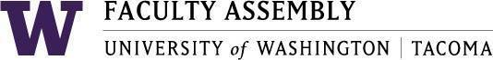

Agenda
Faculty Affairs Committee Meeting
November 18th, 2020 / 12:30pm-1:30 p.m. Zoom

- Recording Permissions/Consent
- Approval of Minutes- Tabled due to OPMA
  - Minutes from 10/19/2020
- Report of Faculty Affairs Chair- Jim Thatcher
  - Faculty Workload

- Discussion Scheduling Classes around COVID-19- Continued
- Governance at UW Tacoma
- Summer Pay for Summer Work: Continued
- Discussion of areas of interest for 2020-21
  - Research for Faculty
  - Tenure/Promotion

- Adjournment

Join Zoom Meeting
https://washington.zoom.us/j/95419519317

Dial by your location
+1 253 215 8782 US (Tacoma)
+1 206 337 9723 US (Seattle)
Meeting ID: 954 1951 9317

