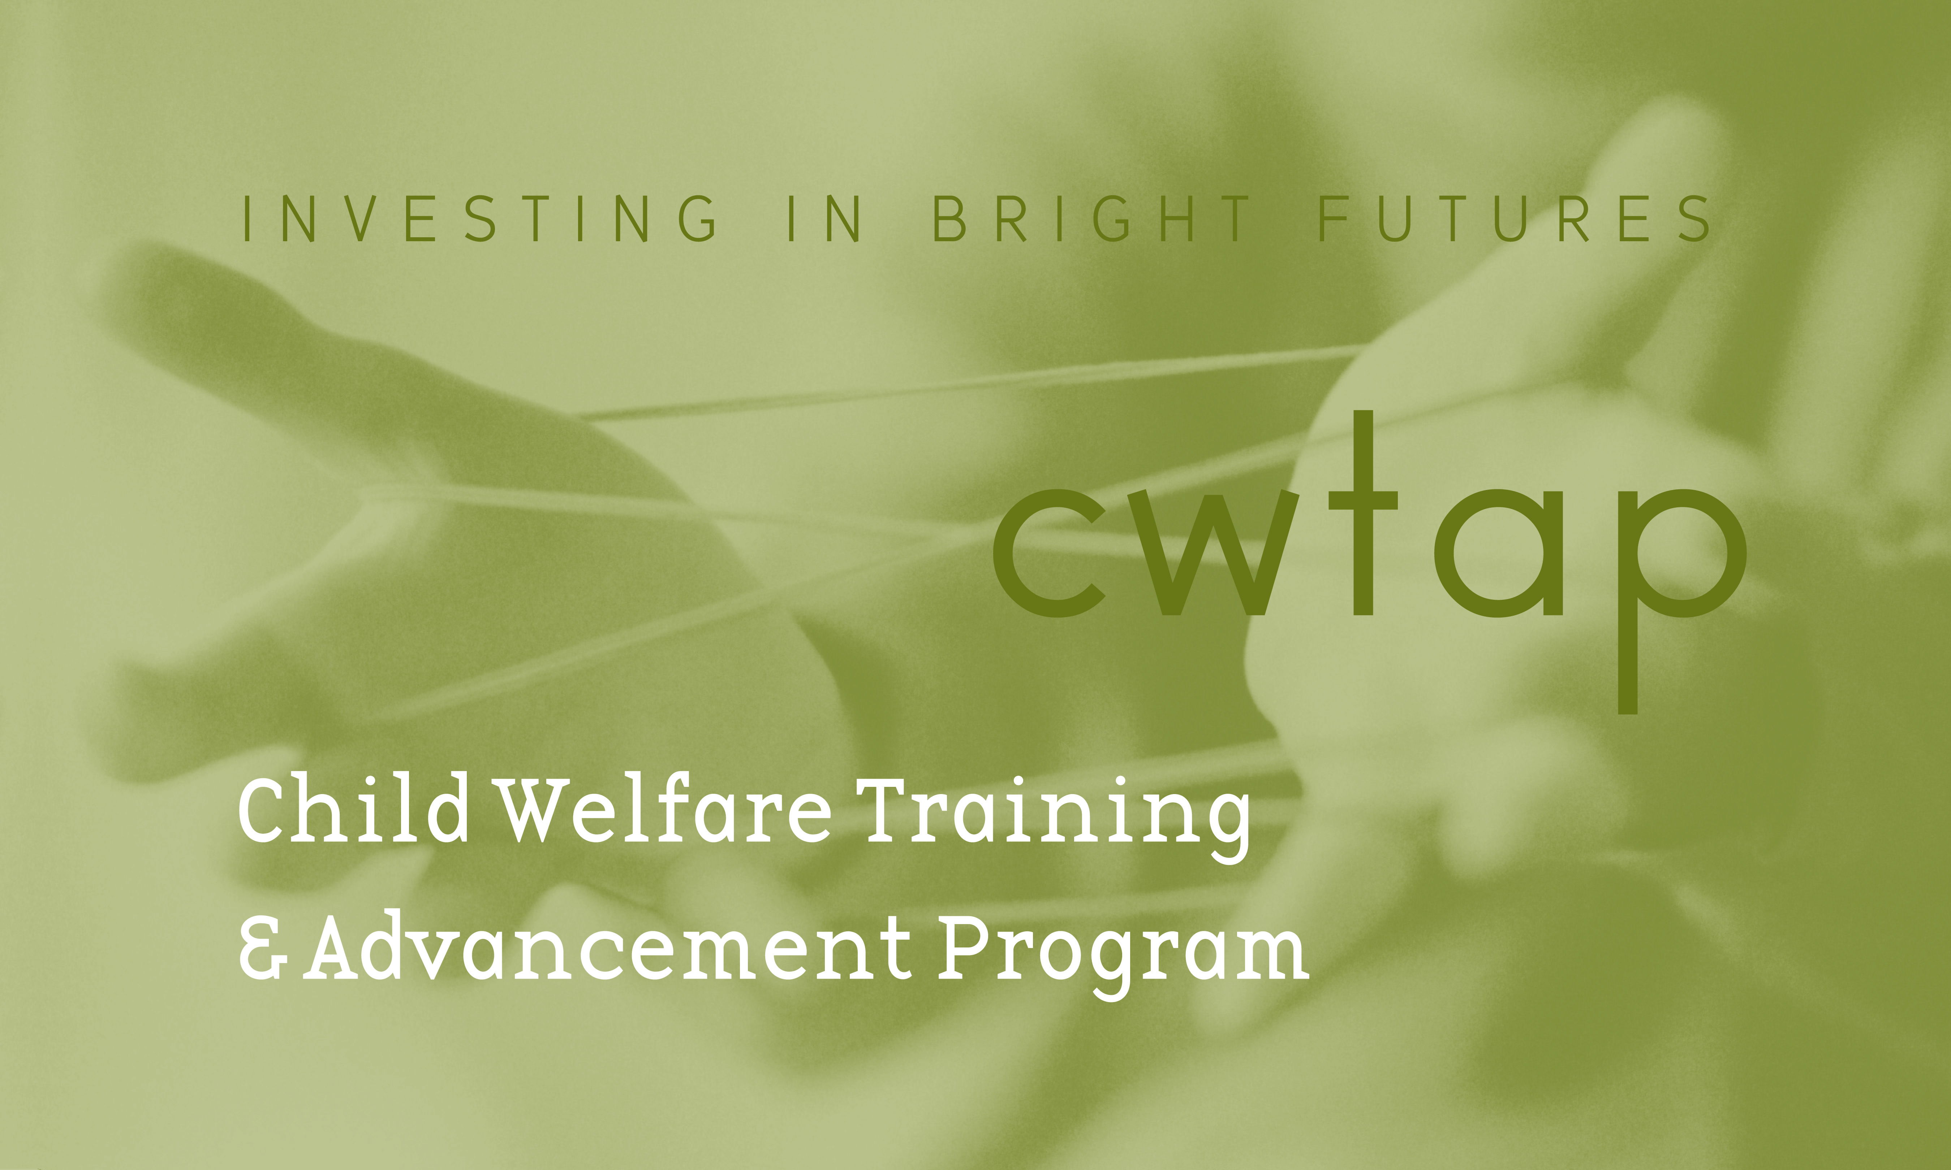

CWTAP Application Checklist

Name -
Program: BASW

Documents should be filled in electronically - not handwritten. Submit your application packet documents (including this checklist) all together (not individually) via email on or before the application deadline to Susan Welk at susanw22@uw.edu.

- Completed CWTAP Application Checklist

- Completed CWTAP Application form

- Copy of unofficial UW Tacoma Transcripts

- Resume (current)

- Two letters of reference (at least one professional)

- Two-page, double spaced essay on:
BASW program applicant
“Why you are interested in working within the public child welfare system”
DCYF Employee applicant
“Why you are interested in continuing to work within the public child welfare system”

- Signed/Approved Department of Children, Youth and Families (DCYF) Employee Participation form (DCYF employees only).

- Complete the Background Authorization process online ASAP. Copy and paste this link https://fortress.wa.gov/dshs/bcs/ using the Google Chrome browser and follow instructions. Forward the email confirmation from the BCS unit (it will appear as: Do_Not_Reply_BCS@dshs.wa.gov) to Susan Welk at susanw22@uw.edu.

- Completed Employee Eligibility (I-9) form (Section one only)

- Photocopies of your Social Security card and driver’s license or passport. (must be clear, visible copies)

- Mandated Reporting Expectations form

